

**Faculty of Engineering and Technology**

**Computer Science Department**

**COMP433 – Group Assignment phase 3**

**Group no: 5**

*Project Name:* Hospital Management System

|  |  |
| --- | --- |
| Students Name | Student Number |
| Ahmad alqattu | 1193000 |
| Mohammad Rabbaa | 1192393 |
| Alaa Salah | 1201772 |
| Mousa Moutan | 1192282 |
| Emad Taweel | 1192943 |

**Phase1**

# Introduction

Our company presents a new project for the next care hospital.

The hospital has had a vision of providing world-class medical services since its inception in 2007 with state-of-the-art facilities and an experienced team of specialized healthcare professionals, they seek to take healthcare to a next level, we will help them out with this budget to make innovative software for the hospital.

One of the main issues in NextCare Hospital suffers from is its outdated methods of storing and updating Patient’s profiles, especially when a patient has long medical history such as suffering from multiple chronic diseases. Currently, the company uses Excel and Google Sheets to store all of its data. Furthermore, many departments in the hospital still use it, like Management Department where they follow ups on various patients’ reports, complaints, and so on all manually using paper and excel which are messy and difficult to use;

Financial Department also suffers from a lack of usable software, you have 3 ways to pay, cash, insurance payer or credit card, which is very important to have useable software to handle financial records in terms of time efficiency and professionality.

managing the schedule for patient visits withMedical staff is a must-to software because it's so badto read and generate in excel.

the new software will wipe these problems and handle them from A to Z, with the database management system providing backup copies of my data daily, and user-friendly interface customized to hospital needs, easy to insert patient profiles and update them automatically when any new data add like diagnoses, lab tests, and rad procedures, add a financial model in which the accountant easily add financial records and display the financial information of patients like insurance and so on, easy report generation on one click you can generate Financial report for patient payment record, same with Management Department where the patient can send a report through a mobile web application and the management have analytics of overall status of the hospital as a report from patient reports and Medical staff reports and the system reports with AI of status in the hospital.

All in all, the hospital's daily operations are outdated, highly vulnerable to efficiency and ease-of-use issues, and will be unable to manage the hospital's growth and vision. The hospital suffers from reliability and maintainability. The solution to these problems involves building customizable software that will enable next care to digitize all of the hospital operations and allow the hospital to streamline its communication in hospital departments and patient Medical staff through well designed API-driven web application approaches.

# System Features

1. **Centralized Database Management System Software:**

As mentioned, the hospital needs to update its methods of storing and retrievinginformation. They need to move away from storing the company’s information in Excel, to a specialized database that will more easily and reliably allow the hospital to perform actions such as adding, updating, and deleting from patient profiles, medical staff, and so on. Doing so will allow the hospital to improve data reliability since much of the reception department’s main issues were duplicated and scattered information.

Furthermore, the database will be centralized to the entire company. This means that instead of every department having separate physical repositories of data; all of the company’s information will be accessible to anyone with the required permissions. This will reduce information duplication, and improve the ease at which information can be retrieved, modified, and read.

Specifically, the database will contain all of the information relevant to hospital employees, medical staff salaries (weekly, monthly, quarterly, and yearly), employee/overtime bonuses, shifts, hours worked, vacation days, employee contracts, and the hospital’s overall hierarchy. The database will also include all non-medical related information such as any/all bills/transactions that the hospital has paid, and needs to pay.

1. **Patient registration and patient profile:**

The program is characterized by ease and high speed in patient registration, the receptionist takes the basic information of the patient from the identity and the personal phone or e-mail and health insurance, if any, that is associated with the data of health insurance companies. And enter it into a user friendly interface program for one time when registering the new patient The patient can log in to the phone program through a patient identification code that was given to him after registration finished, the receptionist can refer the patient to the initial diagnosis all the initial diagnosis information (diagnoses, chronic diseases, previous operations, etc.) is added to the patient's file,or recording him for a specific appointment, according to the specialist doctor.

1. **Phone application:**

Developing a mobile application, which can be downloaded via Google Play and the App Store, allowing the patient who was previously registered in the hospital (for privacy issues) to book advance appointments with doctors to review, and view the available review times for each doctor and the doctor’s official working hours by choosing the appropriate time for him and the doctor to be reviewed and waiting for approval of the reservation from the receptionist.

And the ability to view the patient's profile (the times of previous and upcoming reviews, old diagnoses, reports, laboratory tests, previous operations, and chronic diseases) with the inability to change, the patient can evaluate services and submit complaints and suggestions through the app. Notifying the patient of upcoming reservations and required examinations

1. **emergency registration:**

When the receptionist enters a patient in an emergency situation without registration he can add them to the emergency registration, which is a module where the receptionist enters the bed number, room number, and available information about the patient, then a warning appears repeatedly to the employee that there are emergency records that must be completed as soon as possible. After all the information necessary for registration is available, the registration is transferred to the main registration and removed from the emergency

1. **Doctor's department:**

* appears to the doctor when entering the patient identification code or his name, the initial diagnosis of the patient, and the vital signs that were previously examined by the pathogen (blood pressure, temperature, and blood test) and viewing the patient's file so that the doctor can quickly find out the necessary information without Wasting patient time with a lot of questions. A session is automatically opened for the patient and filled in by the doctor after completing the diagnosis of the case and implementing the patient-specific protocol by writing a full report of the patient's condition The session is closed and added to the patient's profile.
* the doctor can view a schedule of patients' reservations with him.

1. **Section integration:**

The doctor supervising the patient's condition can perform some procedures for the patient (giving medication, vital examination, stating the patient's condition, or transferring the patient to another department) inside the program without the need for paper communication or outside the program and being able to communicate with all other departments in a smooth and simple way that helps facilitate treatment procedures.

program structure helps all departments to stay connected to each other

1. **medical examinations:**

The program contains a high ability to continuously communicate between the program and the biometric devices so that information is automatically entered into the patient's profile without the need to waste time and effort and to avoid human errors. The program supports most types of devices in the testing laboratories.

1. **finance department :**

A simple and easy-to-use accounting interface is shown that contains a full report of the number of working hours for each employee inside the hospital and the vacations; taken through its connection to the identification fingerprint device And the salary calculation for each employee is the calculation of his job position and the agreed salary. Medical expenses are calculated and the hospital's monthly profit percentage is shown in a detailed report And send it automatically to the administration department

1. **Send a reminder:**

There is an additional feature in the program, which is sending a notification that contains a reminder of upcoming reservations, required examinations, and Periodic examinations, if any, by personal phone or e-mail Because some users did not download the application.

1. **Department of Accounting:**

all operations performed by the patient inside the hospital are calculated and an automatic discount is made according to the type of health insurance if any. Where each operation inside the hospital has a pre-priced Payment is made to the receptionist by cash payment or by visa card, taking into account health insurance And show the invoice to the receptionist with the ability to print it to the patient

after paying: the patient's treatment course is automatically sent from the program to the phone number or e-mail

1. **administration Department:**

The program is characterized by showing a comprehensive interface for hospital management that contains a report from the program that is formulated in an easy way and contains a summary of all complaints and suggestions from patients reports or supervisors working inside the hospital and matters related to financial affairs

And some warnings and problems are recorded by the program automatically, such as the end of the oxygen tank or the fullness of the rooms

1. **API-Driven Software**

ease-of-use and maintainability software by building an APIs for nextcare hospital from the ground up, It is easy to communicate with all interfaces, especially with the presence of the mobile application.

# **Software development process**

The software development processes that our team will use depend on the relevant

software features. In general, the entire software system will utilize an incremental

software process. Our team will also build a prototype for the programming user interface

since we will heavily rely on an API-driven solution. Furthermore, our team plans on

building a prototype for the graphical user interfaces of the desktop and websites with the same code without repeating using a new

technology same with mobile with a cross-platform framework like react. Regarding the payment method, we will reuse a formal system for payment.

Finally, since our software will utilize heavily on an API-driven solution; our team will use.

**Phase2**

**Use Case (UML):**

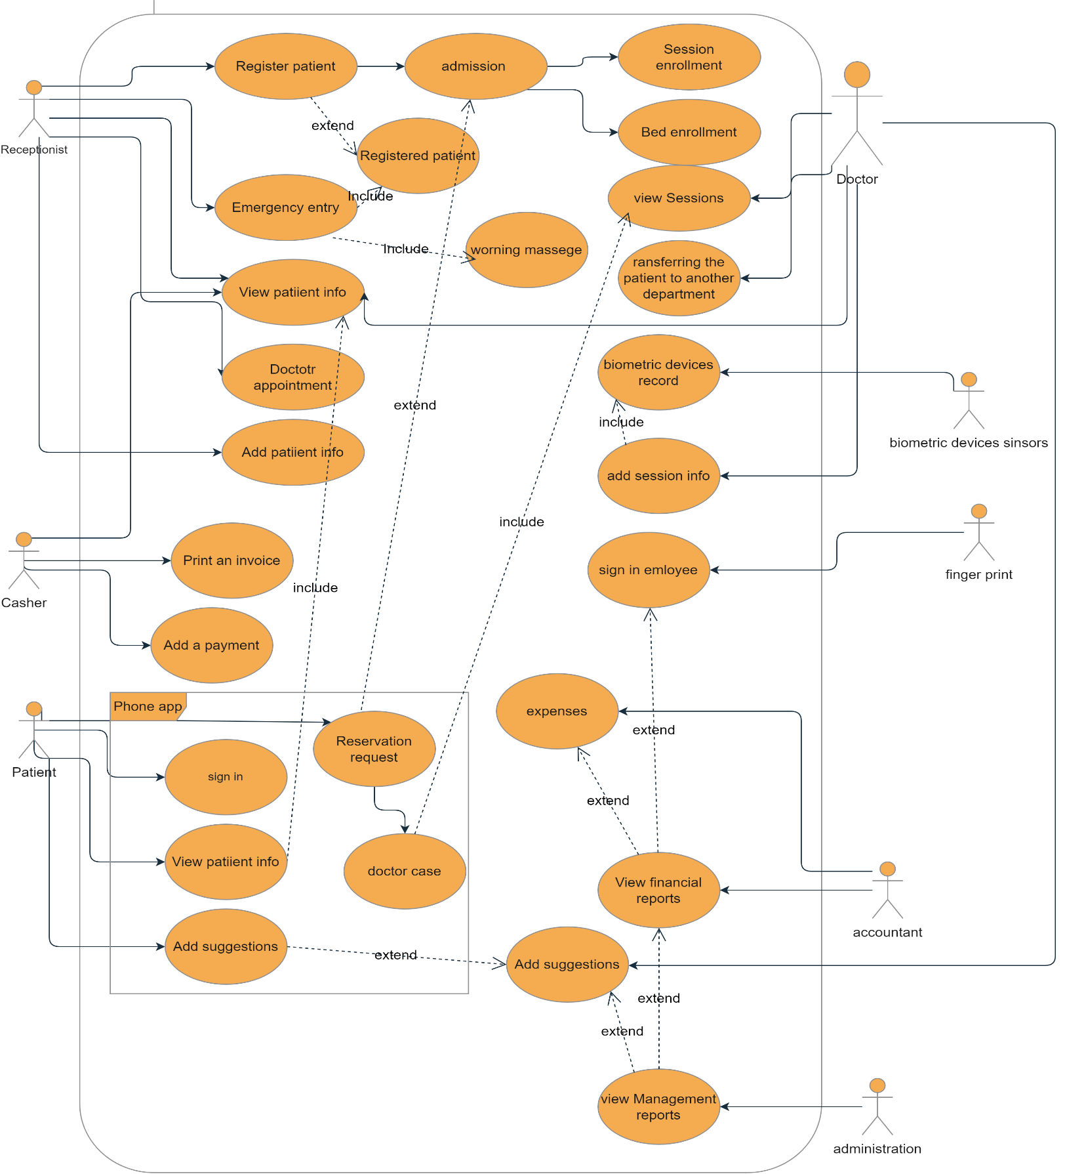

**Description for actor**

**Receptionist**

The receptionist has many abilities: create a file for new patients or modify their information, book appointments with doctors, Patient admission and emergency registration

**Patient**

Patient access to system just via the phone application, he can show all his information and procedures inside the hospital, show doctors availability, book a session with a specific doctor, and he can submit suggestions and complaints

**Doctor**

the doctor displays an appointment schedule, transfers the patient to any other department, and adds session information after each session.

**Accountant**

Displays reports on income and expenses, employee shifts and payroll

**Administration**

he can display administrative reports, from doctors' and patients' complaints, financial reports, and alerts from within the system, such as the number of remaining rooms and the oxygen tank.

**cashier**

Displays all the patient's financial procedures, personal data, insurance type, adding a financial payment in a payment method specified by the patient, and printing invoices.

**biometric devices sensors**

When conducting any examination, the reading is taken from the devices directly to the system automatically and saved in the patient's file.

**Fingerprint hour**

There is a Time Attendance hour through which employees can record the time of attendance of employees by fingerprint and save the record into the system

**Functional & nonfunctional requirements**

**Ahmad qattu 1193000**

U1: the phone app provides a Request to book appointments and view the available review times for each doctor and the doctor’s official working hours by choosing the appropriate time for him and the doctor to be reviewed and waiting for approval of the reservation from the admission department.

System Requirements :

1.1: The phone app should allow patients to request appointments with a specific doctor. This could involve selecting the desired doctor from a list, choosing an available time slot from a calendar, and submitting the request for approval.

1.2: The phone app should provide a list of available review times for each doctor, based on the doctor's official working hours and any existing appointments. The review times should be displayed in a clear and easily understandable format, such as a calendar view.

1.3: The phone app should allow patients to view the doctor's official working hours and available review times. This could involve displaying a calendar view or list of available timeslots, or indicating which timeslots are already booked.

1.4: The phone app should allow the admission department to review and approve or reject appointment requests. This could involve a notification system to warn the admission department.

1.5: then confirmation will send to the patient once the appointment has been approved. This could include a notification or email message indicating the date and time of the appointment, as well as any other relevant details.

U2: Every visit to the doctor must be booked for a prior session to be added to his schedule So that the doctor can check the sessions, and add information to the session when the patient comes

System Requirements :

2.1: The system should allow the doctor to book appointments with patients in advance. This could involve features such as a calendar view, the ability to specify the date and time of the appointment, and the ability to confirm or cancel appointments.

2.2: The system should allow the doctor to add notes or information about the appointment to the session. This could include details about the patient's condition, treatment plan, or any other relevant information.

2.3: The system should allow the doctor to review the details of upcoming appointments or past appointments. This could include the ability to view notes or other information about the appointment.

2.4: The system should send reminders or notifications to the doctor and/or patients to help ensure that appointments are not missed. This could include email or text message notifications, or notifications within the system itself.

**Alaa Salah** **1201772**

Description: Reports are entered by all users of the application,

from a receptionist to a doctor, nurse, and patient. Each user of the application is able to access information that benefits him with specific powers. Thus, they share all users and the application.

UR3: Reports: Everyone should be able to see the reports that they are allowed to read according to a certain priority.

System Requirements :

3.1: the accountant can see the financial reports of financial profits, benefits, and bills and look at them, and also Management report

only for the director to see everything such as the number of patients who entered and how many will stay in the hospital and see the patients' files.

3.2: The patient's diagnoses reports, the treatments he received, and the medications he received, and all of this is covered in the reports of the diagnoses and the doctor, nurse, and patient can see and review them.

3.3: As for discharge a full file must be printed in the patient's illness and the treatment he received, and the invoices are two copies, one for the hospital and a copy for the patient, so that no problem occurs, and to maintain credibility.

3.4: It is not possible to approve the patient’s discharge without the approval of the doctor through the application, or the patient bears his discharge at his own risk.

If this happens, the discharge report will be printed.

3.5: The manager can see all reports and keep them or print them.

3.6: All reports can be viewed, modified and added to via the phone application with

the powers of each individual through his

account from which he entered.

3.7: The diagnoses report cannot be modified except by the doctor and the nurse.

UR4: Any patient can file a complaint against a specific employee or make suggestions to improve the hospital

System Requirements :

4.1: the doctors and patients can submit a complaint or suggestion through a web-based form or phone app just for(patients).

4.1.1: The form or app should include fields for the doctor or patient's contact information, the employee or department involved in the complaint, a description of the complaint or suggestion, and any relevant supporting documents.

4.2: No one can see the complaints and suggestions, except for the manager, for sure, and it will be received as a message through a notification.

4.3: If more than 3 complaints arrive, for example, the uncle of a particular employee, an alert will be sent to the manager via a message.

**Emad Taweel** **1192943**

UR5: Medical Examination: The nurse in charge of the patient connects him to the biometric instruments, presses the test button and waits for the result on screen

System Requirements :

5.1: The system calls a specific API that is able to connect the measuring devices to the system itself.

5.2: After calling the API, the system prepares to take readings from the measuring systems

5.3: Measurements are taken from the systems via the API and transferred to the system's RAM.

5.4: All readings are checked so that if there is an error in the reading, the nurse is given a warning message that there is an error in the reading.

5.5: If there is an abnormal and dangerous reading, the responsible nurse will be notified with a warning message and a warning sound.

5.6: Readings are taken after validation and stored in an alpha-bit format in a file that the doctor opens.

5.7: The readings taken from the patient are shown to the doctor.

5.8: Readings are updated automatically every 10 seconds.

UR6: Report management: the manager can see reports that have been created by clicking on reports:

System Requirements :

6.1: Options containing the type of report and the data it contains are displayed.

6.2: Show an option that contains information and details for each doctor.

6.3: The system generates a prior report on the condition of the hospital in general and allocates other data according to the required type.

6.4: The needs that the hospital lacks are placed to appear at the top of the report in an arranged manner.

6.5: Financial and expense reports are shown, and a small report containing profits and losses is created, or a report is created in a special way, according to the type of report requested by the manager.

**Mousa Moutan** **1192282**

UR7: The System Shall Be Able To Make Registration For Patient And Generate An Unique Id For Each Patient the System Shall Be Able To Search and View an Information About Specific Patient for A Specific Patient the System Shall Be Able To View an Information About Specific Patient the System Shall Be Able To Supply The High Level Security For Patient`s Sick History.

System Requirements :

7.1 : Each patient have a first name, last name ,gender ,phone number, address, id, prescriptions, images : like x-ray or any images important for The patient's medical condition, Pressure, diabetes, an check box for ensure

if the patient have an insurance or note=> then if patient have an insurance view another attribute which is insurance field and it was linked by the insurance company system which give us the members of

his family whih are under the insurance, specific-id : which will be generated by take a first two letter from first name

and first two letter from last name and another six random number, sick history.

7.2 : the user can search for specific patient by his id or by his name(first last) or by his specific-id .

7.3: the user can view all information about patient(first last name, id, specific id,

address, phone number, gender) or his sick history.

7.4: the level of security of patient`s sick history is 65%.

UR8: Prescriptions

8.0.1: The system must be able to book an accommodation for each new patient and a bed until discharge from the hospital.

8.0.2: The System Shall Be Able To Search For His Patient Then System Will view the sick history for this patient.

8.0.3: The doctor shall be able to add prescription in the patient profile and add any image or medical examinations.

8.0.4: The system shall be able to view all Financial issues for patient and the summation of it.

8.0.5: The patient shall be able to view his Financial issues.

8.0.6: The system shall provide the patient to pay by mare than one way.

System Requirements :

8.1: the system will filter all empty bed and any department has empty bed, so the system will have all information about department.

8.2: the doctor will search about patient which he comes to him then firstly the system will view the sick history

of the patient In addition to his name and the Dr can`t avoid the list of sick history until the Dr scroll down to the end of the list then the Dr can get out of sick history page.

8.3: after Dr ends all Medical examinations and Laboratory tests for his patient , he can insert all this information

and images like x-ray ,... to the patient profile .

8.4: in the end the system will calculate all Financial issues about patient and view it in reports to the accountant

and it will view the summation to the manager system.

8.5: The system will provide the patient to pay by visa card and insurance and cash.

**Mohammad Rabbaa 1192393**

UR9: After the patient Download the application on the phone, he opens it and press Log In:

System Requirements :

9.1: The program displays the login screen

9.2 The program will display a screen requesting to enter its national number and password

9.3: If he does not have an account, click on sign up

9.4: The patient enters his national number

9.5: The state of the number is checked. If the number is written incorrectly, an error alert is displayed, with the location of the error marked in red.

9.6: The program enters the database and checks if this number already exists so if it does, it will display an alert that this account already exists and display the Forgot password option

9.7: If the Forgot password option is selected, it will go to the set password page

9.8: If it did not exist before, a page containing the personal information of the owner of this number, such as full name, age, gender, and address, will be displayed after it is filled in automatically

From the data taken from the government database that connected with the system

9.9: The program allows entering a valid e-mail, if available, entering the patient's phone number, and pressing the send code

9.10: The system creates a page for the patient that contains his information so that the user name is the national number and the password is generated randomly from the system

9.11 The system sends a message titled the name of the hospital which contains a welcome message and contains a one-time password to enter in Arabic and English consisting of five numbers

9.12: The password change page will be entered after registering to the program via the password sent. It contains two fields, the first to enter the new password and the other to confirm the password.

9.13 The system User shall be able to specify a password, made up of a minimum of 8 characters. password must include a minimum of three types of characters, alphabets, numbers and special characters.

9.14: The database is updated and the patient's record is saved

UR10: The receptionist selects the patient's emergency registration option and enters it into the emergency registration page

System Requirements :

10.1: The program displays a design for the rooms so that the employee can click on the bed to which the patient wants to enter so that the usable bed appears quickly without searching for it

10.2: The program automatically records the room number and the bed number to which the patient is to be admitted, and the information that can be entered about the patient is entered.

10.3: The employee can click on a bed that is not valid for use, but the program will show a warning alert for confirmation, and then it becomes valid for registration on it

10.4: The program sends alert messages to complete the incomplete registration processes every hour from the start of the registration, with the ability of the administration to change the specified time

10.5: The program allows the employee to modify information about the patient by clicking on the bed the patient is in, or by entering the bed and room numbe.

10.6: The employee can view a comprehensive report issued by the system on all emergency cases and warning messages at any time. It will be automatically added to the general report of the hospital administration and sent to a previously registered email to the hospital administration by pressing the button to send a report and it will be automatically added to the general report of the hospital administration.

10.7: The program allows the employee the ability to cancel an emergency registration with the need to add a comment on the reason for cancellation

10.8: The program is requested update information on the status of beds and rooms from the employee five times a day and save the changes

10.9: In the event that the beds are full in all emergency rooms, the program allows the transfer of a sick bed from an emergency room to another non-emergency room, but with a signal to the employee that he is an emergency patient

10.10: The program allows the employee to add a new patient bed

10.11: The program allows the employee to complete the emergency registration of a patient and transfer it to the regular registration, and empty the bed automatically after updating the information

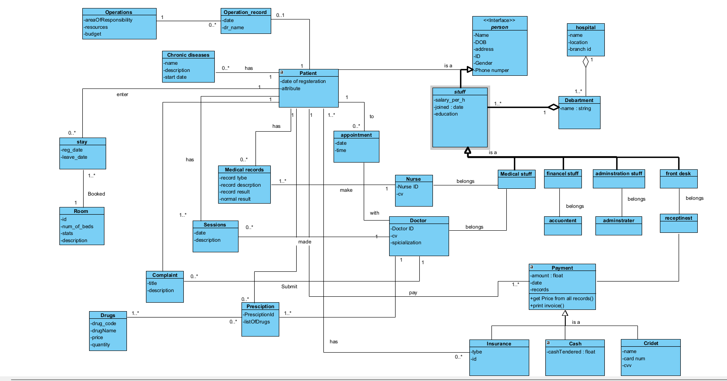**Phase3**

**Class diagram**

Ahmad luay qatu 1193000:

U1: the phone app provides a Request to book appointments and view the available review times for each doctor and the doctor’s official working hours by choosing the appropriate time for him and the doctor to be reviewed and waiting for approval of the reservation from the admission department.

System Requirements :

1.1: The phone app should allow patients to request appointments with a specific doctor. This could involve selecting the desired doctor from a list, choosing an available time slot from a calendar, and submitting the request for approval.

1.2: The phone app should provide a list of available review times for each doctor, based on the doctor's official working hours and any existing appointments. The review times should be displayed in a clear and easily understandable format, such as a calendar view.

1.3: The phone app should allow patients to view the doctor's official working hours and available review times. This could involve displaying a calendar view or list of available timeslots, or indicating which timeslots are already booked.

1.4: The phone app should allow the admission department to review and approve or reject appointment requests. This could involve a notification system to warn the admission department.

1.5: then confirmation will send to the patient once the appointment has been approved. This could include a notification or email message indicating the date and time of the appointment, as well as any other relevant details.

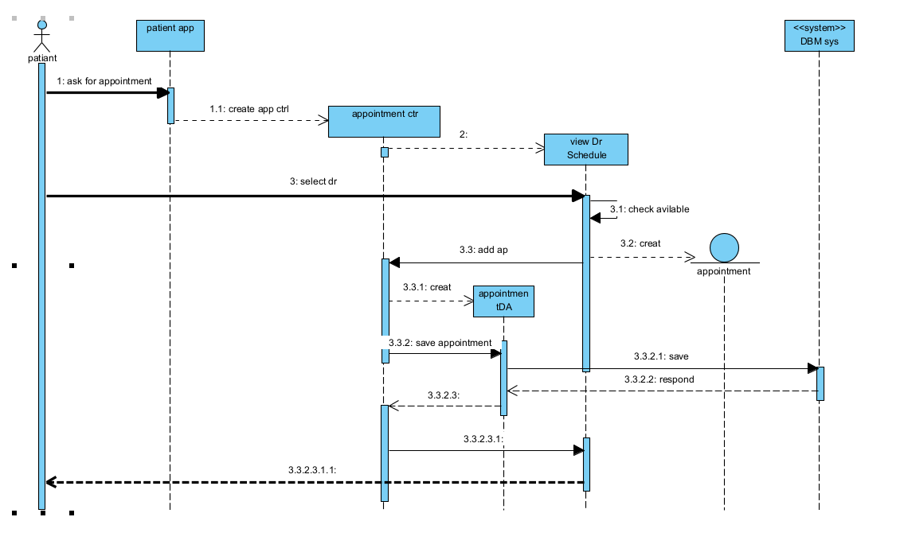

Mohammad Rabbaa 1192393:

UR9: After the patient Download the application on the phone, he opens it and press Log In:

System Requirements :

9.1: The program displays the login screen

9.2 The program will display a screen requesting to enter its national number and password

9.3: If he does not have an account, click on sign up

9.4: The patient enters his national number

9.5: The state of the number is checked. If the number is written incorrectly, an error alert is displayed, with the location of the error marked in red.

9.6: The program enters the database and checks if this number already exists so if it does, it will display an alert that this account already exists and display the Forgot password option

9.7: If the Forgot password option is selected, it will go to the set password page

9.8: If it did not exist before, a page containing the personal information of the owner of this number, such as full name, age, gender, and address, will be displayed after it is filled in automatically

From the data taken from the government database that connected with the system

9.9: The program allows entering a valid e-mail, if available, entering the patient's phone number, and pressing the send code

9.10: The system creates a page for the patient that contains his information so that the user name is the national number and the password is generated randomly from the system

9.11 The system sends a message titled the name of the hospital which contains a welcome message and contains a one-time password to enter in Arabic and English consisting of five numbers

9.12: The password change page will be entered after registering to the program via the password sent. It contains two fields, the first to enter the new password and the other to confirm the password.

9.13 The system User shall be able to specify a password, made up of a minimum of 8 characters. password must include a minimum of three types of characters, alphabets, numbers and special characters.

9.14: The database is updated and the patient's record is saved

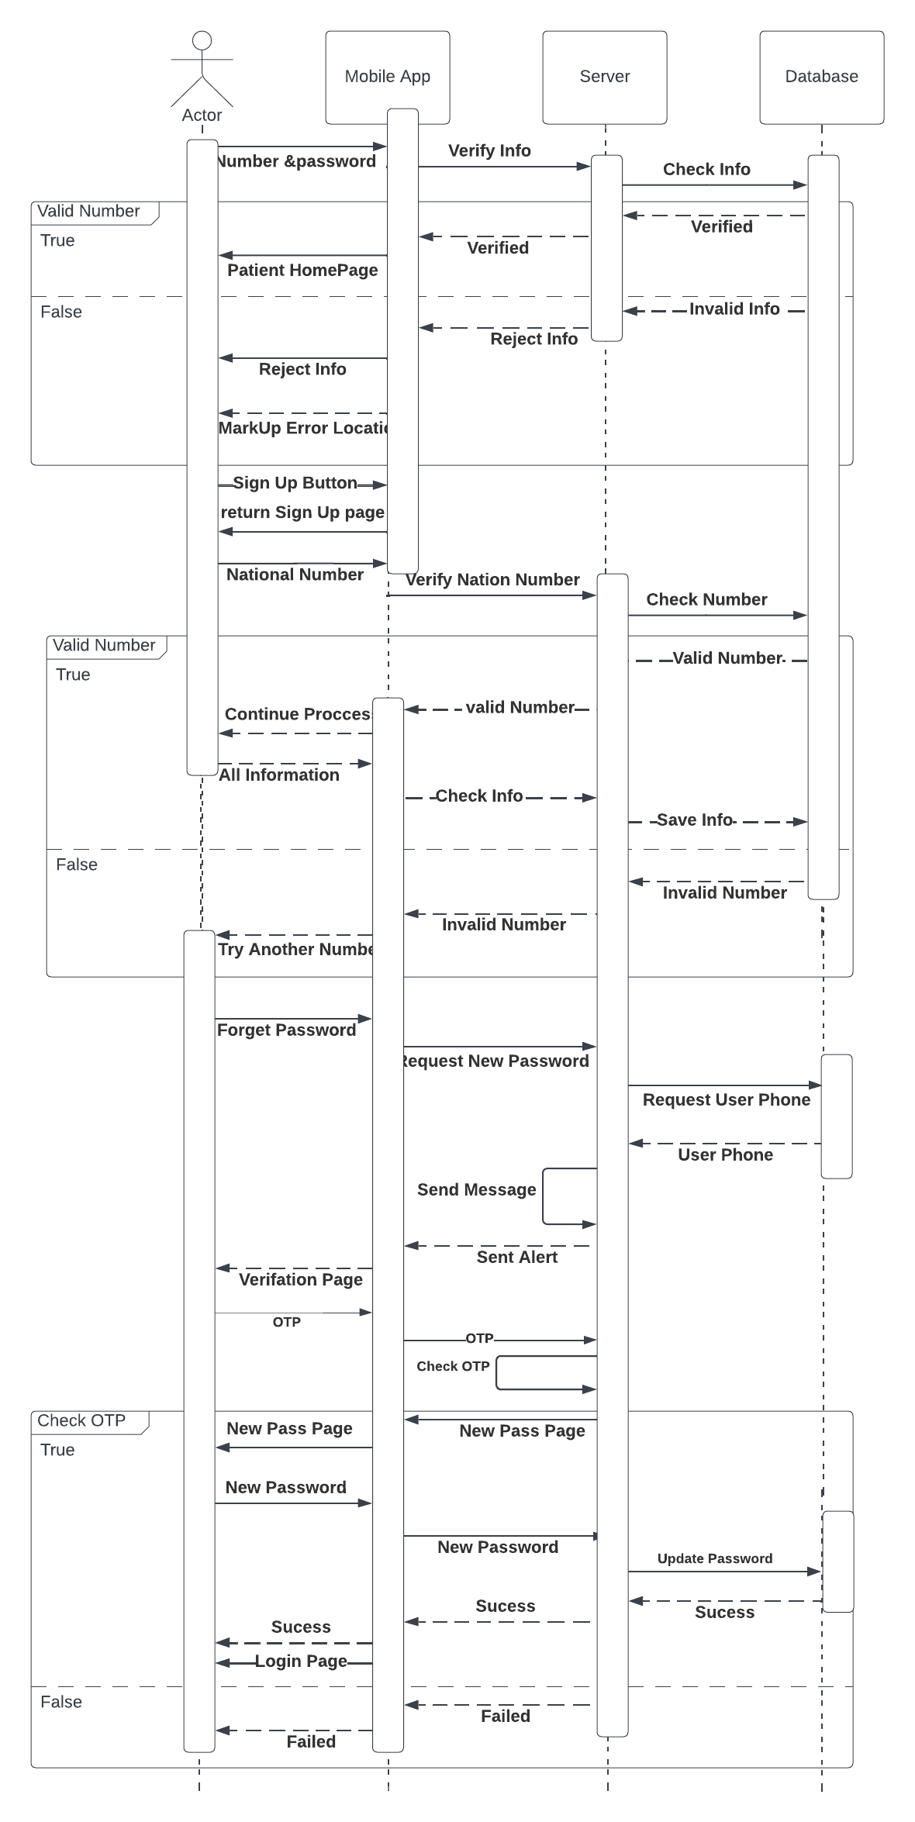

Alaa Salah 1201772:

UR3: Reports: Everyone should be able to see the reports that they are allowed to read according to a certain priority.

System Requirements :

3.1: the accountant can see the financial reports of financial profits, benefits, and bills and look at them, and also Management report

only for the director to see everything such as the number of patients who entered and how many will stay in the hospital and see the patients' files.

3.2: The patient's diagnoses reports, the treatments he received, and the medications he received, and all of this is covered in the reports of the diagnoses and the doctor, nurse, and patient can see and review them.

3.3: As for discharge a full file must be printed in the patient's illness and the treatment he received, and the invoices are two copies, one for the hospital and a copy for the patient, so that no problem occurs, and to maintain credibility.

3.4: It is not possible to approve the patient’s discharge without the approval of the doctor through the application, or the patient bears his discharge at his own risk.

If this happens, the discharge report will be printed.

3.5: The manager can see all reports and keep them or print them.

3.6: All reports can be viewed, modified and added to via the phone application with

the powers of each individual through his

account from which he entered.

3.7: The diagnoses report cannot be modified except by the doctor and the nurse.

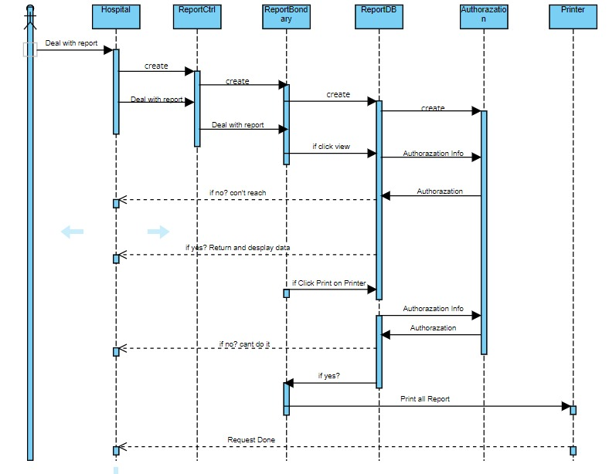

**Mousa Moutan 1192282:**

UR7: The System Shall Be Able To Make Registration For Patient And Generate An Unique Id For Each Patient the System Shall Be Able To Search and View an Information About Specific Patient for A Specific Patient the System Shall Be Able To View an Information About Specific Patient the System Shall Be Able To Supply The High Level Security For Patient`s Sick History.

System Requirements :

7.1 : Each patient have a first name, last name ,gender ,phone number, address, id, prescriptions, images : like x-ray or any images important for The patient's medical condition, Pressure, diabetes, an check box for ensure

if the patient have an insurance or note=> then if patient have an insurance view another attribute which is insurance field and it was linked by the insurance company system which give us the members of

his family whih are under the insurance, specific-id : which will be generated by take a first two letter from first name

and first two letter from last name and another six random number, sick history.

7.2 : the user can search for specific patient by his id or by his name(first last) or by his specific-id .

7.3: the user can view all information about patient(first last name, id, specific id,

address, phone number, gender) or his sick history.

7.4: the level of security of patient`s sick history is 65%.

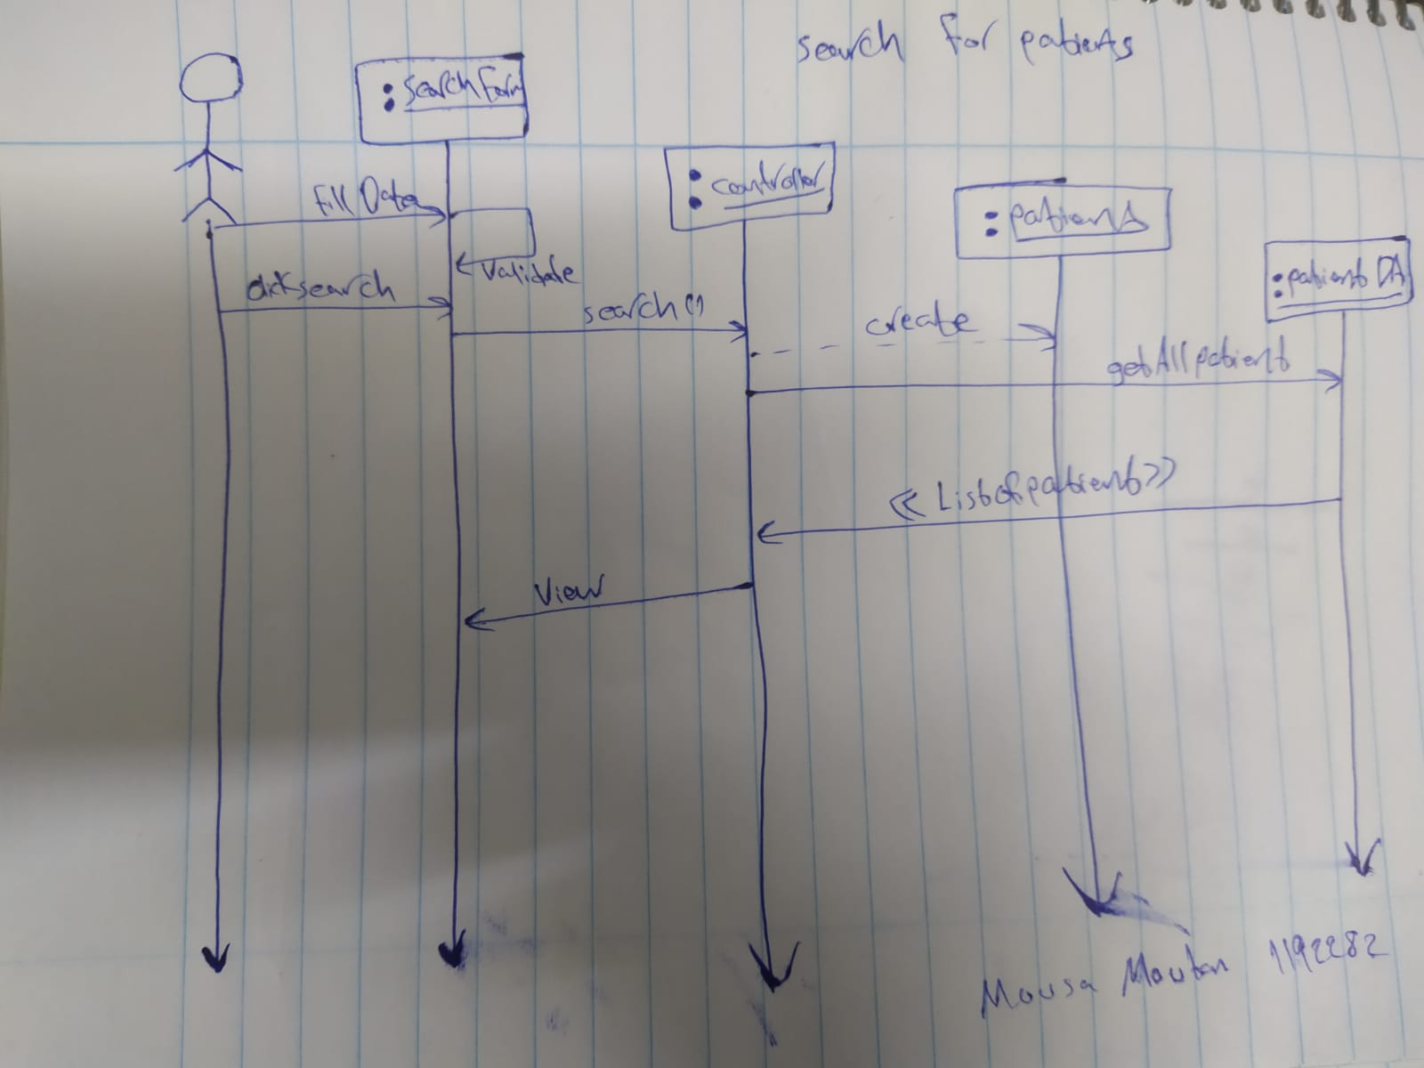

Emad Taweel 1192943: